French University in Armenia

Faculty of Informatics and Applied Mathematics

FINAL REPORT

Project SA

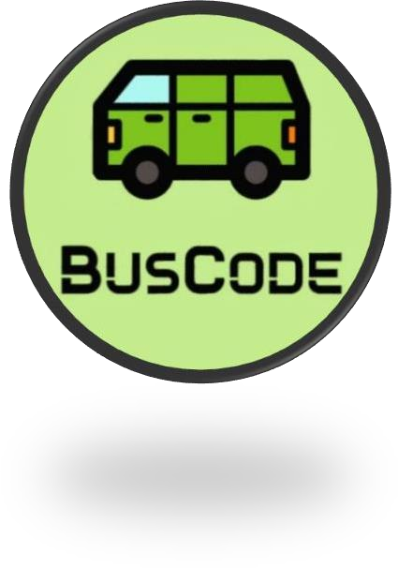

Students:

Metaksya Shahbazyan , Armen Shahinyan, Ani Tadevosyan, Ani Mnatsakanyan, Davit Muradyan

Date:20.03.2023

# Abstract

During this semester within Project SA, we came up with innovative ideas, identified needs for our country, developed a business idea, researched the market, found problems and gave them solutions.

Here is the link to our project’s YouTube video: <https://youtu.be/Pcy8oTac3Mw>

## Content

Abstract 2

Introduction 4

1. Problem Statement 5
   1. Comparative Research within the existing solutions 6
   2. Comparative research Summary 16
   3. Requirements Analysis with Rene Descartes's square 17
   4. SWOT for BusCode 23
   5. Business Model Canvas 25
   6. Requirements Description for BusCode 26
2. Implementation 27
   1. User Behavior Study 27
      1. The persona description for Users 27
      2. User Story 28
3. Software Requirements Specifications 29
   1. Introduction 29

3.1.1. Purpose 29

* + 1. Document Conventions 29
    2. Intended Audience and Reading Suggestions 29
    3. Project Scope 30
  1. Overall Description 31
     1. Product Perspective 31
     2. Product Functions 31
     3. User classes and Characteristics 31
     4. Operating Environment 32
     5. Design and Implementation Constraints 33
     6. User Documentation 33
     7. Assumptions and Dependencies 34

1. Demo Version 35
2. Lessons learned during Implementation 37

Conclusion 38

References 39

Annex 1. Tools used during Project SA 40

Annex 2. Weekly Reports 41

**Introduction**

In Armenia, using public transport can be quite a big problem, and there are a couple of reasons for that.

First, they do not always arrive on time. Buses are mostly crowded. Drivers do not always follow the rules of security. Some buses are in really bad condition. Passengers often do not have coins with them, and because of that drivers must count and give them change, which makes the paying process rather long, and irritates both the driver and the other passengers.

Our suggestion is the following:

Creating an app, which will allow

To pay for bus rides using mobile phones, by scanning the QR codes inserted in buses. To show the paths of buses, their destinations and bus-stops on a map, using geolocation. To have personal accounts with your bus-fare payment history.

Insert certain sensors at the entrance of buses, which will allow the users to see how crowded the bus they want to use at that moment is.

Make the buses rides more frequent to prevent overcrowding.

## Problem Statement

During this project, my personal tasks were investigating the world market to make comparative research of one of the existing solutions, coming up with requirements for our project to make the “Descartes's square” table, making the second main parts/paragraphs/columns of the Business Model Canvas, the SWOT analysis, User/Customer Behavior studies and SRS. Participate in making the demo version and make the video.

## Comparative Research within the existing solutions

One of the payment apps which enables to pay also by QR, is AliPay.

Today, Alipay has become a digital payment leader and constructed a financial ecosystem. It is more than a secure and convenient payment method. With this giant e-wallet, merchants can launch marketing campaigns, give away coupons, get more detailed information on clients’ preferences…

It is reported that all Chinese tourists have an Alipay App in their mobile phone. On average, over 40% of transactions are via this popular e-wallet. It is becoming one of the most accepted payment methods abroad among Chinese people.

Here is the table of research, including AliPay’s functional areas, their requirements, and the capability of providing those requirements.

|  |  |  |
| --- | --- | --- |
| **FUNCTIONAL AREA** | **REQUIREMENTS** | **CAPABILITY** |
| User Registration and Authentication | Phone Number Verification | Yes.  Alipay requires users to verify their phone number during the registration process. |
| User Registration and Authentication | Password Strength | Yes.  Alipay requires users to create a strong password to protect their account from unauthorized access. |
| User Registration and Authentication | Consent and Agreement | Yes. |

|  |  |  |
| --- | --- | --- |
|  |  | Alipay should require users to give their explicit consent and agreement to the terms and conditions of using the app, including how their data is used and protected. |
| QR Code Scanning | Compatibility | Yes.  Alipay is compatible with a wide range of QR code standards, including static and dynamic QR codes, to support various use cases and payment scenarios. |
| QR Code Scanning | Security | Yes.  Alipay has ensured that QR code scanning is secure and protected against fraud, hacking, and other malicious activities. This requires the use of encryption, secure authentication methods, and other security measures to protect user data. |
| QR Code Scanning | Integration | Yes.  Alipay is seamlessly integrated with merchants' point-of-sale |

|  |  |  |
| --- | --- | --- |
|  |  | (POS) systems to enable smooth payment processing and reduce the risk of errors or delays. |
| QR Code Scanning | User experience: | Yes.  Alipay provides a fast and user-friendly QR code scanning feature that allows users to quickly scan and make payments using their mobile devices. |
| QR Code Scanning | QR code scanner hardware | No.  Alipay does not require users to have any specific QR code scanner hardware to scan QR codes. Users can simply use their mobile devices to scan QR codes and make payments. |
| QR Code Scanning | Geographical location | No.  Alipay does not have any specific requirements for the geographical location of users or merchants who use the QR code scanning feature. However, users and merchants must comply with relevant laws and regulations in their respective jurisdictions. |

|  |  |  |
| --- | --- | --- |
|  |  |  |
| Payment history | Transaction records | Yes.  Alipay maintains a record of all transactions made through the platform, including payments, transfers, and refunds. |
| Payment history | Search and filter | Yes.  Alipay allows users to search and filter their transaction history based on various criteria, such as date, amount, and transaction type. |
| Payment history | Privacy protection | Yes.  Alipay has strict privacy policies and data protection measures in place to ensure that users' transaction history data is kept confidential and secure. |
| Payment history | Transaction details | Yes.  Alipay provides users with detailed information about each transaction, including the transaction amount, date and time, merchant name or |

|  |  |  |
| --- | --- | --- |
|  |  | account details, and payment status. |
| Payment history | Transaction editing | No.  Alipay does not allow users to edit or modify transaction details once they are recorded in the transaction history. |
| Payment history | Payment history archiving | No.  Alipay does not have a feature to automatically archive or store older transaction history data beyond a certain time frame. |
| Customer support | Live Chat Support | Yes.  Alipay provides live chat support to its users via its mobile app and website. This allows users to quickly connect with customer support representatives and get their issues resolved in real-time. |
| Customer support | Knowledge Base | Yes. |

|  |  |  |
| --- | --- | --- |
|  |  | Alipay has a comprehensive knowledge base that provides users with answers to frequently asked questions about the platform, its features, and services. |
| Customer support | Email Support | Yes.  Alipay also provides email support to its users, which allows them to raise and track their issues in a structured manner. |
| Customer support | 24/7 support | No.  Alipay does not provide 24/7 customer support. The support hours are limited to specific times in each region. |
| Customer support | Multilingual Support | No.  Alipay's customer support is mostly available in Mandarin Chinese, with limited support for other languages. |
| Customer support | Remote Assistance | No. |

|  |  |  |
| --- | --- | --- |
|  |  | Alipay does not provide remote assistance to its users, which can be useful in resolving complex issues. |
| Payment processing | Fast Payment Processing | Yes.  Alipay processes payments quickly, usually within seconds, allowing users to complete transactions smoothly and efficiently. |
| Payment processing | Secure Payment Gateway | Yes.  Alipay provides a secure payment gateway that ensures the safety of users' payment information and transactions. |
| Payment processing | Fraud Prevention | Yes.  Alipay has measures in place to prevent fraud and unauthorized transactions, including real- time monitoring and machine learning-based fraud detection systems. |
| Payment processing | Offline Payment Processing | No. |

|  |  |  |
| --- | --- | --- |
|  |  | Alipay does not support offline payment processing, which may be a limitation in certain situations. |
| Payment processing | Recurring Payments | No.  Alipay does not offer the option for users to set up recurring payments for services such as subscriptions or monthly bills. |
| Payment processing | Split Payments | No.  Alipay does not provide a feature for users to split payments between multiple payment methods or recipients. |
| Rewards and Loyalty Programs | Points-based Rewards | Yes.  Alipay offers a points-based rewards system that allows users to earn points for using the app and making purchases, which can be redeemed for discounts and other rewards. |
| Rewards and Loyalty Programs | User-friendly Interface | Yes.  Alipay's rewards and loyalty programs are integrated into its app, providing users with a |

|  |  |  |
| --- | --- | --- |
|  |  | user-friendly and convenient way to track their rewards and redeem them. |
| Rewards and Loyalty Programs | Cashback Rewards | No.  Alipay does not offer cashback rewards, which may be a limitation for users who prefer this type of reward. |
| Rewards and Loyalty Programs | Personalized Offers | No.  Alipay does not provide personalized offers based on users' individual preferences and behavior, which may reduce the effectiveness of its rewards and loyalty programs. |
| Public Transportation | Integration | Yes.  There is integration with various public transportation systems, such as subways, buses, and trains, in multiple cities across China. |
| Public Transportation | Availability | No.  Limited availability outside of China, with most of the public transportation integrations being domestic. |

|  |  |  |
| --- | --- | --- |
|  |  |  |
| Public Transportation | Map | Yes.  There’s ability to view transportation routes and stops on a map within the Alipay app. |
| Public Transportation | Fare-size | Yes.  Automatic fare calculation based on the distance travelled, eliminating the need for users to manually calculate fares. |
|  | **Additional requirements** | **Necessity** |
|  | A smartphone with a camera and the ability to run the Alipay app. | yes |
|  | A stable internet connection to complete transactions and access real-time transportation information. | Yes |
|  | Compliance with local transportation regulations and requirements. | Yes |
|  | A registered Alipay account with a linked bank card or other payment method. | Yes |

|  |  |  |
| --- | --- | --- |
|  |  |  |
|  | Having a physical transportation card or ticket. | No |
|  | Having a physical transportation card or ticket. | No |

## Comparative research Summary

Seeing these details about AliPay, we can say that it surely meets international convenience and security standards. It is an app for payments in all spheres, with AliPay you can pay for online shopping, mobile phone top-ups, utility bills, transportation, restaurants and food delivery, entertainment, and travel.

In comparison, our app BusCode will be used only for paying for bus rides. It will not include other payment methods except for QR code scanning, and that will be beneficial for its ease of use, less data, and local use.

## Requirements Analysis with Rene Descartes's square

Here are the features of the app I prepared and presented with Descartes's square.

|  |  |  |  |  |
| --- | --- | --- | --- | --- |
| Feature |  questions | What happens if it happens | What happens if it doesn’t happen | What won’t  happen if this happens | What won’t  happen if this doesn’t happen |
| Creating an  account with your name and surname | Users would be able to  personalize their accounts with their name and surname, which would make it easier for them to identify their  accounts and  manage their transactions. | There may be a higher risk of fraudulent transactions or unauthorized use of the app, as it may be more difficult for the service provider to verify the identity of the  user. | Inability to recover lost or stolen funds,  The service provider may have limited data to analyze user behavior and patterns | If there aren’t tied user's name and surname, it will not be very possible for service providers to  verify the identity of the user and prevent fraudulent  transactions. |
| Inserting your phone number in your profile | Service providers would be able to contact the user more easily if there are issues with their account, also, it can be used to verify the user's identity in case  of a lost or stolen | Service providers may have fewer options to verify the user's identity in case of unauthorized access to the account. This could potentially  make the user's | Some users may be concerned about privacy issues if their phone number is linked to their account. But with our app, they must be confident in the service  provider's ability | Users will not be able to benefit from any security measures that require a phone number, such as two-factor authentication. |

|  |  |  |  |  |
| --- | --- | --- | --- | --- |
|  | phone or  unauthorized  access to the account. | account more vulnerable to security breaches  or fraud. | to protect their personal information. |  |
| Attaching your Credit Card to your profile | The payment process will be faster and more convenient for users, as they will not need to input their credit card information every time, they make a payment. Users will be able to track their payment history and view their transaction records through the payment app, which can be useful for  budgeting and expense tracking. | Users will need to carry cash or a physical payment card to pay for their bus fares, which may be inconvenient or impractical for some users.  The payment process may be slower and less efficient, as users will need to input their payment information every time, they make a payment. | Users will not need to worry about the security of their credit card information, as the payment app will need to have strong security measures in place to protect users' payment information, such as encryption and two-factor authentication. | The payment app will not be able to provide the convenience and security of credit card payments |
| Having a  password | Users will need  to enter their | If the feature of  having a | Unauthorized  users will not be | Users may not  be defended |

|  |  |  |  |  |
| --- | --- | --- | --- | --- |
|  | password each time they use the payment app, which will help to prevent unauthorized transactions or activities. | password for a QR code bus payment app doesn't exist, it can present a security risk for the app and its users. | able to access a user's payment information without knowing their password.  The payment app will not be able to be used by anyone who does not have the correct password, which will help to prevent fraudulent activities. | against fraud or theft, as anyone who has access to their device could potentially use the payment app without their consent. |
| Getting notifications | Users can receive real-time updates on their account balance and transaction history, which can help them keep track of their spending and avoid overdrafts or other issues.  Users can be  alerted when a payment has | Without notifications, users may not be aware of  unauthorized or fraudulent transactions, which can put their account at risk.  Users may be uninformed of any changes or updates to the  app or their | Users will not miss important information or updates about their account, as they will receive notifications in real-time. Users may not be alerted when a payment has been made or when their balance falls below a certain  threshold, which | The app may not be convenient to use, as users may need to manually check their account balance or transaction history, which can be time- consuming . |

|  |  |  |  |  |
| --- | --- | --- | --- | --- |
|  | been made or when their  balance falls below a certain threshold, which can help them avoid missed payments or other issues. | account, which can lead to confusion or misunderstandin gs. | can result in missed payments or overdrafts. |  |
| Existence of “Help center” on the app | Users would have a place to go to get assistance with any issues or questions they may have about the app. The Help Centre  could provide answers to frequently asked questions, provide step-by- step guides for common tasks, and offer a way to contact customer support  if necessary. | Users may face difficulties in finding answers to their questions or resolving issues they encounter while using the app. They may need to rely on external sources such as online forums or customer service hotlines, which may not always provide accurate or timely  information. | With a help center available, users may not need to reach out to the company's customer support team as  frequently, which could lead to a reduction in customer support costs for the company. | Without a help center, users may not be able to get their questions answered or doubts cleared. |

|  |  |  |  |  |
| --- | --- | --- | --- | --- |
| High level- security providence | A payment app with a high level of security will be less  vulnerable to hacking attempts or other forms of fraud. This can protect users  from financial loss or identity theft. | Increased vulnerability to fraud and hacking attempts: A  payment app  with weak security measures can be vulnerable to hacking attempts, which can result in financial loss or identity theft for users. | The presence of a high level of security provision for a QR code bus payment app can interfere the absence of these: improved protection against fraud and hacking attempts, increased user confidence, compliance with industry standards, strong user authentication, and better privacy  protection. | Payment apps  that lack  sufficient security measures may not have strong authentication processes. |
| Option of choosing different languages | Users will be able to select the language they prefer for the app's interface and communications. This will  enhance the user  experience, as | The app will likely only be available in one language, which could create barriers for users who don't speak that language fluently. | The app may not be limited to users who speak the default language, as users can choose to use the app in their preferred language. This  can lead to a | Users who do not speak the default language of the app may find it difficult to use the app effectively.  Tourists will be  able to use the app easily |

|  |  |  |  |  |
| --- | --- | --- | --- | --- |
|  | users who are not fluent in the default language of the app can use the app more comfortably and effectively.  Tourists will be able to use the  app easily | It could limit the potential user base of the app, as people who speak other languages may not be able to use it effectively or at all. | wider user base for the app. | Tourists will not be able to use the app easily |

## SWOT for BusCode

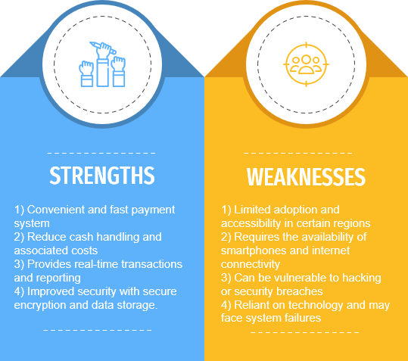

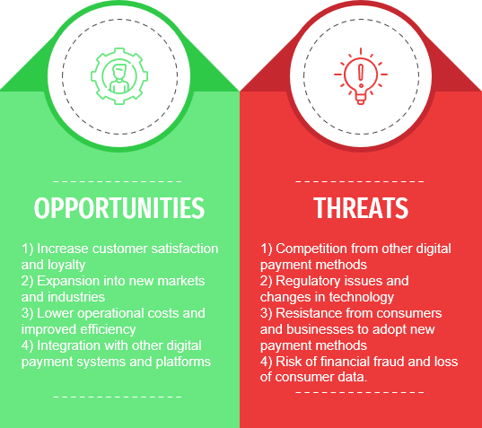

[SWOT](https://1drv.ms/p/s!An27-tSS-qwOtkHDIxE3Zy4lBrgB?e=5V4gbL)

## Business Model Canvas

[Business Canvas](https://1drv.ms/w/s!An27-tSS-qwOtkXHbRQ7y6sZpWu3?e=7G9IYo)

## Requirements Description for BusCode

For using the modern and convenient method of paying for bus fares through QR code, the following requirements must be taken into consideration before putting in place a system that accepts this kind of payment:

QR codes in buses: To verify payment, passengers must be able to scan the QR code with a mobile device.

Installment handling: Validation, authorization, and settlement must all be handled securely by the system when QR code payments are made.

Integration with providers of payment: To make payment processing easier, the system needs to be able to connect to a variety of payment providers, like mobile wallets or credit card companies.

Customer service: In order to assist customers with any issues, the system must include customer support features like a help desk, FAQs.

Integration with current paying systems: To ensure a smooth transition to QR code payments, the system needs to be compatible with existing payment systems.

Privacy and security: To safeguard the financial and personal information of customers, the system needs to be constructed with robust privacy and security features.

Scalability: It is necessary for the system to be able to handle a big number of users and transactions without compromising performance or dependability.

Accessibility: The app must be able to be downloaded and used by both Android and IOS users.

Also, as there may be elderly people who may not have a smartphone, we thought of a solution, as giving them special cards, which they can use for paying bus fares.

## Implementation

* 1. **User Behavior Study**

## The persona description for Users (fitional)

Here is one of the possible user persona’s description:

(All the other user and customer descriptions are presented in my groupmates’ reports.)

## User Story

Hrayr is a student, living in Yerevan, who takes bus rides occasionally, to go to the university. He’s inclined to modernization of life, and to making different aspects of it easier with the help of technologies.

He typically uses public transportation to get to and from university, and he finds it inconvenient to carry cash or wait in line to pay the fare every time he boards the bus. With the QR coded bus payment app, he can simply scan a code on his phone when he boards the bus, and the fare will be automatically deducted from his account.

This will save him time and make his daily commute more efficient. He also appreciates the convenience of being able to track his payment history and manage his account through the app.

## Software Requirements Specifications

* 1. **Introduction**

## 3.1.1. Purpose

The QR Code Bus Payment App is a mobile application that allows users to pay for their bus fares by scanning QR codes displayed on buses. This app aims to provide a convenient and efficient payment method for bus passengers and eliminate the need for physical cash payments.

## Document Conventions

Document Title: Software Requirements Specification for QR Code Bus Payment App. Document Information:

Author: Metaksya Shahbazyan Date of Creation: March 20, 2023

Version: 1.0

Font and Formatting: All text is typed in the font “Times New Roman”. Bold is used for headings. References: This document references relevant transportation regulations or payment industry standards.

## Intended Audience and Reading Suggestions

End-users: The vast majority of the people who use QR code-based payment methods are the individuals who will use the payment app to pay. End-users can be consumers, merchants, or anyone who needs to send or receive payments.

Developers: The payment method might also be informative to developers who design and build payment systems. Developers may need to know how the payment method works technically, such as its architecture, APIs, and how it works with payment gateways

User Manuals: User manuals can show you how to use the payment method and fix common problems step by step.

Industry Reports and Analysis: Market trends, adoption rates, and changes in the law that affect QR code-based payment methods can be seen in industry reports and analyses.

News and Blog Posts: News and blog posts can keep you up to date on the latest developments and trends in QR code-based payment methods.

## Project Scope

The following features will be included in the QR Code Bus Payment App:

QR Code Scanner - The app will have a built-in QR code scanner that allows users to scan QR codes displayed on buses to pay for their bus fares.

Payment Gateway Integration - The app will integrate with payment gateways to enable seamless payment transactions.

User Account Creation - Users will be able to create accounts within the app, which will allow them to store their payment information and transaction history.

Transaction History - The app will maintain a record of all transactions made through the app.

Customer Support - The app will provide customer support to address any issues that may arise during app usage.

## Overall Description

## Product Perspective

The app is a standalone product available on both Android and iOS platforms. It is designed to simplify the payment process for bus passengers and provide a fast, secure, and reliable payment method. The app integrates with payment gateways to enable seamless payment transactions and provides customer support to address any issues that may arise during app usage.

The app assumes that buses will be equipped with QR codes readable by the app, users will have access to the internet, and users will have mobile devices compatible with the app.

The prospects of this product can be rated as a high one, due to the fast growth and development of the usage of technologies in our everyday life.

## Product Functions

Scan QR Codes - The app will be able to scan QR codes displayed on buses to initiate payment transactions. Process Payments - The app will process payment transactions through integrated payment gateways.

Store User Information - The app will store user information, including payment information and transaction history.

Provide Customer Support - The app will provide customer support to address any issues that may arise during app usage.

## User classes and Characteristics

Bus drivers and passengers will be the system's main users. Bus riders must have a smartphone app to pay by scanning the bus's QR code, while bus drivers will be required to check customer payments.

There can be different types of passengers:

Young people, who will have no problem using the app.

Elderly people, who, in case of not having a smartphone, can use special cards.

## Operating Environment

Hardware Requirements: For QR code scanning and internet connectivity for payment transactions, the user's mobile device must have an autofocus camera. On tablets and smartphones with the necessary hardware, the software can be utilized.

Software Requirements: For the app to work properly, the operating system must be at least Android 5.0 or iOS

10.0. To scan QR codes and finalize payments, the app will also require use of the device's camera and internet connection.

Bus Service Provider: The buses need to have QR codes that the app can read. For the app to obtain fare information and verify payment transactions, it needs to be integrated with the bus service provider's system.

Internet connection: In order to process payments and get information from the bus service provider's system, the app has to be connected to the internet.

Security: The app is responsible for ensuring the privacy and security of user information, payment transactions, and correspondence with the bus service provider and payment gateway. The app has to abide by all applicable security laws and regulations.

## Design and Implementation Constraints

Technical Constraints: The app must be designed and implemented to work seamlessly on a range of mobile devices and operating systems. The app should be optimized for performance and speed, and it should be able to handle a high volume of transactions without any downtime or disruptions. The app should also be able to scan QR codes quickly and accurately.

Resource Constraints: The app development team must work within the constraints of the available resources, including time, budget, and staffing. The app should be designed to be cost-effective and scalable, so it can accommodate an increasing number of users and transactions over time.

Regulatory Constraints: The app must comply with applicable laws and regulations, including data privacy and security regulations. The app must also comply with payment industry regulations and standards, such as the Payment Card Industry Data Security Standard (PCI DSS).

Integration Constraints: The app must be designed to integrate seamlessly with the bus service provider's system and the payment gateway. This requires careful coordination and planning to ensure that the app can communicate effectively with these systems and retrieve the necessary data to complete transactions.

Usability Constraints: The app must be designed to be easy to use and intuitive for users. The app's user interface should be designed to minimize confusion and errors, and it should be accessible to a wide range of users, including those with disabilities.

## User Documentation

User Guide: A comprehensive user guide that provides step-by-step instructions on how to download, install, and use the app. The guide should cover all the features and functions of the app, including how to scan QR codes, make payments, and view transaction history.

FAQs: A list of frequently asked questions (FAQs) that address common issues and concerns that users may have. The FAQs should cover topics such as account registration, payment processing, and security.

Tutorials: A set of video or written tutorials that provide more detailed guidance on specific app features or functions. Tutorials can be particularly helpful for users who are new to mobile payment apps.

Terms and Conditions: The terms and conditions should be accessible to users and should provide clear information on the app's data privacy and security policies, as well as user responsibilities and limitations.

## Assumptions and Dependencies

The assumptions and dependencies of the QR Code Bus Payment App require careful consideration to ensure that the app can function as intended and provide a seamless user experience. The app development team must work closely with partners and stakeholders to address any issues related to assumptions and dependencies during the app's development and deployment.

Availability of Mobile Devices: The app assumes that users have access to mobile devices that are compatible with the app's operating system and that can scan QR codes.

Availability of Internet Connectivity: The app assumes that users have access to reliable internet connectivity to download and use the app.

Integration with Payment Gateway: The app is dependent on the integration with the payment gateway to process payments and complete transactions. Any issues with the payment gateway can impact the app's functionality.

Coordination with Bus Service Provider: The app is dependent on coordination with the bus service provider to access relevant data, such as bus schedules, routes, and fare information.

Data Privacy and Security: The app assumes that users are willing to share personal information and payment details with the app and that appropriate data privacy and security measures are in place to protect user information.

Availability of Technical Resources: The app assumes that the necessary technical resources, such as hardware and software, are available for the app's development, deployment, and ongoing maintenance.

## Demo Version

Here is the demo version of our app.

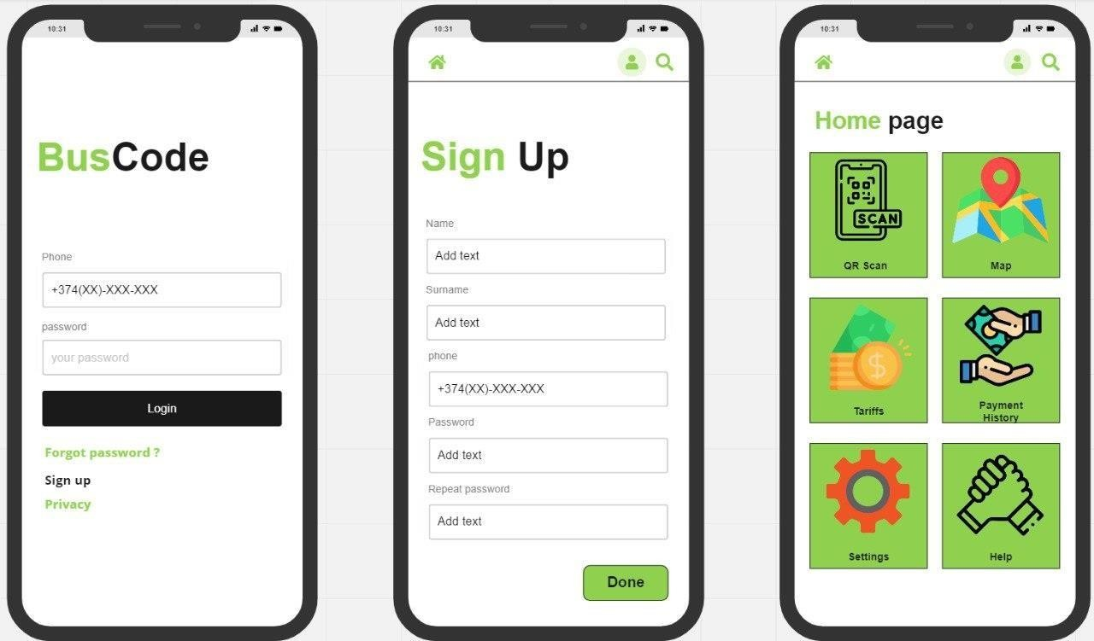

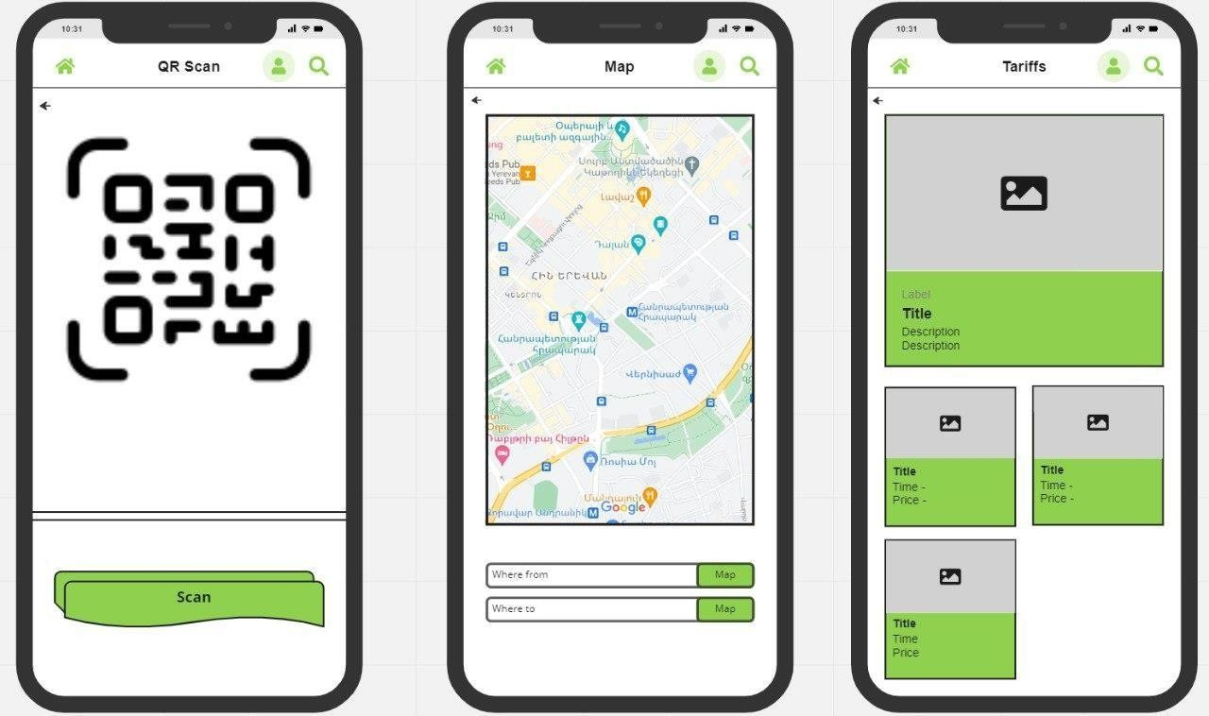

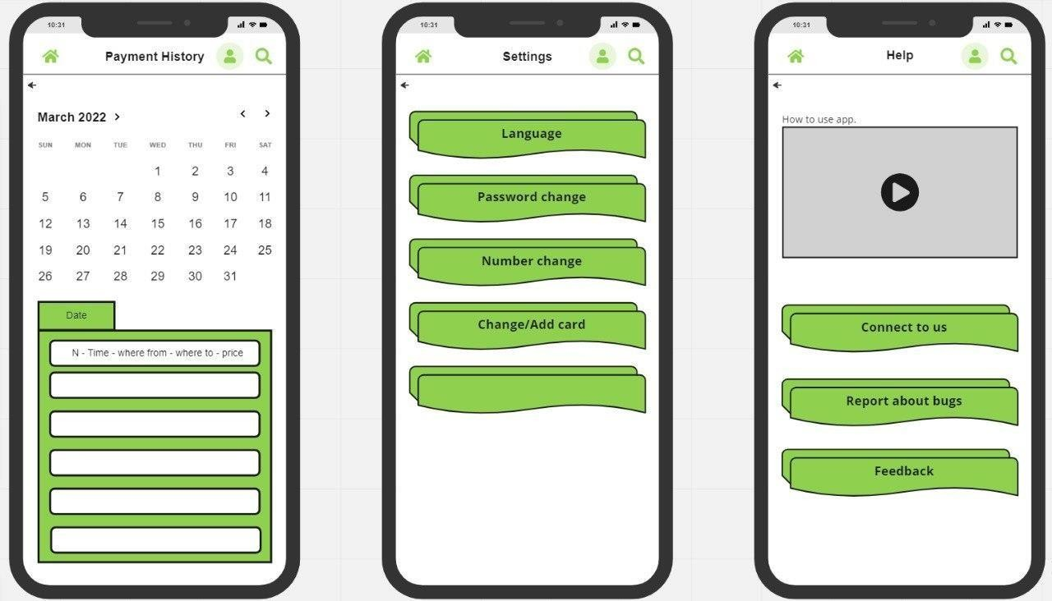

## Lessons learned during Implementation

The implementation of the QR Code Bus Payment App offers several valuable lessons that can be applied to future app development and deployment projects. By taking these lessons learned into consideration, app developers can increase the likelihood of success and provide a seamless user experience for app users.

One of the most important lessons learned during the implementation of the QR Code Bus Payment App is the importance of user testing.

Successful app implementation requires close collaboration between all stakeholders, including app developers, bus service providers, and payment gateway providers. Collaboration helps to ensure that everyone is working towards a common goal and that the app meets the needs of all parties involved.

In today's digital age, data privacy and security are critical considerations for any app. The QR Code Bus Payment App must comply with all relevant data privacy and security regulations to protect user information and payment details.

Technical issues are inevitable during app implementation, and it is important to have a plan in place to address any issues as quickly as possible. It is also important to provide users with clear information and guidance on how to address any technical issues they may encounter.

## Conclusion

Bus passengers can quickly and securely pay for their fares using their mobile devices with the help of the QR Code Bus Payment App. The user's needs, technical limitations, data privacy and security, as well as cooperation with bus service providers and payment gateway providers, must all be carefully considered when developing and implementing the app.

A lot of useful lessons have been learned during the development and implementation process, including the value of user testing, teamwork, data privacy and security, ongoing maintenance, and communication. These lessons can be used to improve the likelihood of success and give app users a seamless experience in future app development and deployment projects.

In conclusion, the QR Code Bus Payment App is a significant advancement in the comfort and effectiveness of public transportation, and it has the power to completely change how bus passengers pay for their fares. It will be interesting to see how payment methods like the QR Code Bus Payment App develop and advance as technology improves, making public transportation even more available and practical for people all over the world.

## References

To make this document, I have used various sources of information, they are presented below:

[AliPay](https://global.alipay.com/platform/site/ihome) for comparative research

[https://www.perforce.com/blog/alm/how-write-software-requirements-specification-srs-](https://www.perforce.com/blog/alm/how-write-software-requirements-specification-srs-document#%3A~%3Atext%3DTool%20for%20SRS-%2CWhat%20Is%20a%20Software%20Requirements%20Specification%20(SRS)%20Document%3F%2Cstakeholders%20(business%2C%20users)) [document#:~:text=Tool%20for%20SRS-](https://www.perforce.com/blog/alm/how-write-software-requirements-specification-srs-document#%3A~%3Atext%3DTool%20for%20SRS-%2CWhat%20Is%20a%20Software%20Requirements%20Specification%20(SRS)%20Document%3F%2Cstakeholders%20(business%2C%20users))

[,What%20Is%20a%20Software%20Requirements%20Specification%20(SRS)%20Document%3F,stakeholders](https://www.perforce.com/blog/alm/how-write-software-requirements-specification-srs-document#%3A~%3Atext%3DTool%20for%20SRS-%2CWhat%20Is%20a%20Software%20Requirements%20Specification%20(SRS)%20Document%3F%2Cstakeholders%20(business%2C%20users))

[%20(business%2C%20users).](https://www.perforce.com/blog/alm/how-write-software-requirements-specification-srs-document#%3A~%3Atext%3DTool%20for%20SRS-%2CWhat%20Is%20a%20Software%20Requirements%20Specification%20(SRS)%20Document%3F%2Cstakeholders%20(business%2C%20users))

(For SRS research)

[https://www.perforce.com/blog/alm/how-write-software-requirements-specification-srs-](https://www.perforce.com/blog/alm/how-write-software-requirements-specification-srs-document#%3A~%3Atext%3DTool%20for%20SRS-%2CWhat%20Is%20a%20Software%20Requirements%20Specification%20(SRS)%20Document%3F%2Cstakeholders%20(business%2C%20users)) [document#:~:text=Tool%20for%20SRS-](https://www.perforce.com/blog/alm/how-write-software-requirements-specification-srs-document#%3A~%3Atext%3DTool%20for%20SRS-%2CWhat%20Is%20a%20Software%20Requirements%20Specification%20(SRS)%20Document%3F%2Cstakeholders%20(business%2C%20users))

[,What%20Is%20a%20Software%20Requirements%20Specification%20(SRS)%20Document%3F,stakeholders](https://www.perforce.com/blog/alm/how-write-software-requirements-specification-srs-document#%3A~%3Atext%3DTool%20for%20SRS-%2CWhat%20Is%20a%20Software%20Requirements%20Specification%20(SRS)%20Document%3F%2Cstakeholders%20(business%2C%20users))

[%20(business%2C%20users).](https://www.perforce.com/blog/alm/how-write-software-requirements-specification-srs-document#%3A~%3Atext%3DTool%20for%20SRS-%2CWhat%20Is%20a%20Software%20Requirements%20Specification%20(SRS)%20Document%3F%2Cstakeholders%20(business%2C%20users))

(For SRS research)

<https://krazytech.com/projects/sample-software-requirements-specificationsrs-report-airline-database>

(For SRS research)

[https://supercode.com/use-case/qr-codes-for-](https://supercode.com/use-case/qr-codes-for-transportation#%3A~%3Atext%3DUse%20QR%20codes%20for%20payment%2Ctokens%20is%20no%20longer%20necessary.%20%20) [transportation#:~:text=Use%20QR%20codes%20for%20payment,tokens%20is%20no%20longer%20necessary.](https://supercode.com/use-case/qr-codes-for-transportation#%3A~%3Atext%3DUse%20QR%20codes%20for%20payment%2Ctokens%20is%20no%20longer%20necessary.%20%20) (For QR research)

## Annex 1. Tools used during Project SA

<https://canvanizer.com/downloads/business_model_canvas_poster.pdf>

for Business Model Canvas template [PPT online](https://chrome.google.com/webstore/detail/powerpoint-online/mdafamggmaaaginooondinjgkgcbpnhp?hl=ru) for making SWOT

[Canva](https://www.canva.com/) for making personas descriptions

[WordOnline](https://chrome.google.com/webstore/detail/word-online/fiombgjlkfpdpkbhfioofeeinbehmajg?hl=ru) for making the whole document

[Chat GPT](https://chat.openai.com/chat) for very fast obtainable data and help with the document structure

[SteveAI](https://www.steve.a/) for making the YouTube video

## Annex 2. Weekly Reports

Meeting 1

## 24.01.202

**Topics covered Tasks of the day**

We discussed the main idea of our task

We chose a field and found some solutions to its problems

**Tasks for the week between workshop sessions** Choose 1 from problems in our country Investigate the market

## Individual

Count (approximately) the number of people who use buses every day (Areg Sahakyan) Check the percentage of overcrowded buses (Anna Ohanyan)

Differentiate the age differences of passengers (Metaksya Shahbazyan)

Check how many people use QR codes for payments in their every-day life (Magdalena Sheroyan) Think of solutions for elderly, who don’t have smartphones. (Gor Barkhudaryan)

## Difficulties met during task completing

Lack of full knowledge on Project SA

Meeting 2

## 31.01.2023

**Topics covered during the day Tasks for the day**

## Theory

Understand how many countries use similar products Understand what competition we have

## For the project-product team

Created a logo and a name for our app

## Tasks for the week between workshop sessions

Define features of the project

Divide features between group members

## Difficulties met during task completing

**Lack of hands-on expertise for the task implementation**

*Yes*

## Lack of time for practicing

*Yes*

Meeting 3

## 07.02.2023

**Topics covered during the day Tasks for the day**

## Theory

Start the comparative research between existing solutions Understanding potential users as well as financial partners. **Praxis**

## For the project-product team

Discussion of the solutions that are relevant for the task **Tasks for the week between workshop sessions Praxis**

Complete the undone Comparative research parts

## For the project-product team

Discussed strengths and weaknesses of our project

## Individual

Comparative Research on Transit (Anna Ohanyan) Comparative Research on AliPay (Metaksya Shahbazyan) Comparative Research on Idram (Magdalena Sheroyan) Comparative Research on WeChat (Areg Sahakyan) Comparative Research on Moovit (Gor Barkhudaryan)

## Difficulties met during task completing Lack of trustful resources

*Yes*

## Lack of professional help

*Yes*

## Lack of time for practicing

*Yes*

Meeting 4

## 14.02.2023

**Topics covered during the day Tasks for the day**

## Theory

Learn about the SWOT and Business Model Canvas The beginning of the user behavior study

## Praxis

We started writhing the demo version of SWOT Searching and analyzing target users

## For the project-product team

Dividing the tasks required for the user behavior **Tasks for the week between workshop sessions Theory**

Finish the Requirements Description

## Praxis

We filled in the Requirements Description part

## For the project-product team Individual

SWOT (Areg Sahakyan, Magdalena Sheroyan)

Business Model Canvas (Anna Ohanyan, Metaksya Shahbazyan, Gor Barkhudaryan)

## Difficulties met during task completing Lack of the academic understanding

*Yes, little bit confused about user behavior study*

## Lack of hands-on expertise for the task implementation

*Yes*

## Lack of time for practicing

*No*

## If any other problems or difficulties

*None*

Meeting 5

## 21.02.2023

**Topics covered during the day Tasks for the day**

## Theory

Begin researching Persona description for Users and Costumers Start the Software Requirements Specification

## Praxis

Completed a search for any and all relevant information regarding the application's users

## For the project-product team

Dividing personas descriptions among group members Wrapping up Business Model Canvas and SWOT **Tasks for the week between workshop sessions Theory**

Starting User Story

## Praxis

We proceeded with the Software Requirements Specifications

## For the project-product team Individual

Each of us wrote their own Introduction and Abstract parts Each group member search information about The Personas

**Difficulties met during task completing Lack of the academic understanding** *Yes, we had trouble getting the SRS going.*

## Lack of hands-on expertise for the task implementation

*No*

## Lack of time for practicing

*No*

## If any other problems or difficulties

*None*

Meeting 6

## 28.02.2023

**Topics covered during the day Tasks for the day**

## Theory

Finish the SRS

## Praxis

The Software Requirements Specification has been finalized.

## Tasks for the week between workshop sessions Theory

Starting to write the report in stages

## Praxis

**For the project-product team:**

## Individual

Each of group members started to write their own Conclusions and Lesson Learned sections.

## Difficulties met during task completing Lack of the academic understanding *No*

**Lack of hands-on expertise for the task implementation**

*No*

## Lack of time for practicing

*No*

## If any other problems or difficulties

*Some parts of SRS were hard to understand.*

Meeting 7

## 07.03.2023

**Topics covered during the day Tasks for the day**

## Theory

Choose the style and creative process of the video.

Set the parameters for the demo version of the application.

## Praxis

We have begun production on our video. We started the application process

## For the project-product team

**Tasks for the week between workshop sessions Theory**

Finish the whole report

## Praxis

**For the project-product team:**

## Individual

The production of the video (Metaksya Shahbazyan, Magdalena Sheroyan) Application establishment (Anna Ohanyan, Gor Barkhudaryan, Areg Sahakyan)

## Difficulties met during task completing Lack of the academic understanding *No*

**Lack of hands-on expertise for the task implementation**

*No*

## Lack of time for practicing

*No*

## If any other problems or difficulties

*There were no further problems*